August 2020

## EBRA EPI-Cluster

**Mission**: Establish a collaborative framework for the coordinated actions of epilepsy research in Europe

***EPI-cluster leadership***

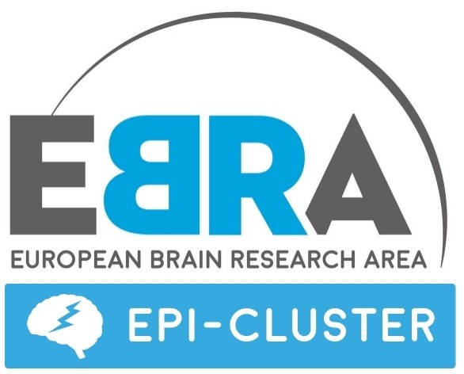The EPI-Cluster2 was established in 2019 under EBRA as a coordinating action for the European epilepsy research community. The consortium requested support for an EBRA Cluster based on the projects that participated in EpiXchange[1] and the main stakeholder (professional and patient) organisations including European Alliance Epilepsy (EAE), International Bureau for Epilepsy (IBE) and International League against Epilepsy (ILAE). The leadership of EPI-Cluster comprises 10 internationally-recognized scientists and clinicians in the field and the leaders of the seven projects that came together under EpiXchange as well as leaders from patient and professional organisations. The EPI-cluster is led by a chair and a co-chair.

***EPI-cluster’ stakeholders***

The EPI-Cluster intends to expand its membership to include affiliated members, other stakeholders and other projects with strong scientific synergies that were not able to participate in EpiXchange (H2020 ITN projects such as ECMED, EU-GliaPhD and SynaNET). The cluster seeks opportunities and interaction with other funded non-epilepsy projects within the Human Brain Project, JPND and ERA-NET and seeks to act at global level. The aim of such expansion is to ensure that all stakeholders perspectives are represented in the cluster. These are perspectives from:

* Academics/researchers: basic and translational science
* Clinicians/caregivers
* Infrastructure/data representatives
* Patient/patient representatives
* Industry representatives

***EPI-Cluster subgroups***

EPI-Cluster plans to create 4 subgroups. These subgroups will coordinate the 3 remaining EBRA activities of the EPI-Cluster. The planned subgroups are:

(1) Synthesis: Planning meetings and support the development of the programme for a European Forum on Epilepsy.

(2) Policy & sustainability: Agreeing key research challenges, potential funding opportunities for EPI-Cluster community.

(3) Innovation & industry: Responsible for contacting and engaging with SMEs and Pharma.

(4) Data and research infrastructure: Coordinating interactions with partners such as HBP and supporting collaborations using our existing resources (e.g. biosamples ).

Each subgroup will be led by 1 or 2 leadership members. This task is currently ongoing.

***EPI-cluster priorities, objectives and perspectives***

The primary objective EPI-Cluster is to establish a collaborative framework for the coordinated actions of epilepsy research in Europe, based around the partnerships and research priorities. The proposed initiatives are to:

* Maintain, enhance and advance the existing collaboration and cooperation between multi-scale epilepsy research projects and their partner organisations in Europe.
* Expand the network, bringing in new European-led epilepsy-focused projects and non-epilepsy-focused
* Develop a global funding initiative on epilepsy research across agencies bringing in internationally outstanding academic, industry and other partners.
* Advance research on core topics including mechanisms, diagnosis, treatment and patient care.
* Increase and integrate the engagement of persons with epilepsy and their representatives in the design and execution of research activities.
* Enhance resource-sharing among research groups by establishing mechanisms for safe and effective exchange of resources, models and big data.
* Develop researcher exchange mechanisms to promote knowledge and training between groups.
* Develop an operational preclinical trial network and enhance clinical trial structures for epilepsy in Europe based on eHealth and genetic/clinical phenotyping tools to enable patient stratification.

|  |
| --- |
| **EPI-Cluster strategic priorities** |
| * **Advance** the existing **collaboration** * Expand the network * Advance research on core topics * Enhance resource-sharing * Develop a preclinical trial network and enhance clinical trial structures * Develop researcher exchange mechanisms * **Increase** **engagement** of persons with epilepsy and their representatives * Develop a global funding initiative on epilepsy research across agencies |

Figure 1: Objectives of EPI-Cluster

Six research and innovation priority topics have been identified by the EPI-Cluster:

* Disease-modifying and personalised medicines for epilepsy and their delivery systems
* Target-led biomarker and diagnostics discovery and validation
* Innovative models for diagnostics and target development
* Digitalisation and personal monitoring for independent living in epilepsy
* Coordination of research infrastructures and the Epilepsy data ecosystem
* Funding initiatives and integration to society, industry and regulatory space

The different stakeholder perspectives (ref. meeting June 2020) are the following:

* **All stakeholders:** Strong agreement for the value of the EPI-CLUSTER community and interest in being affiliated.
* **All stakeholders:** Epilepsy-related project coordinators supportive of joining forces.
* **Infrastructures:** Strong synergies and opportunities for EPI-CLUSTER to work with the Human Brain Project on human EEG/imaging and with QUEST on preclinical studies.
* **Industry:** Keen to see more small biotech/SMEs enter the area and potential to EPI-CLUSTER for preclinical trial “network”.
* **Patients:** Enthusiastic to contribute to EPI-CLUSTER through expert groups.

1. epiXchange 2018 brought together Europe’s best-brains-to-pave-the-way-for-future-epilepsy-research