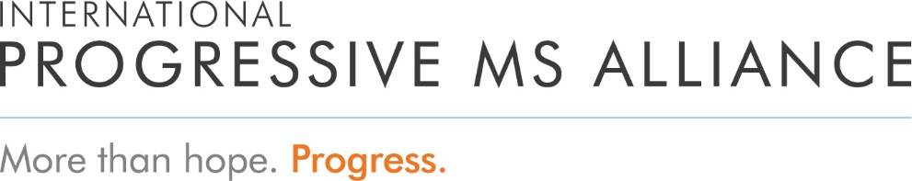

*Mission*

To accelerate the development of effective treatments for people with progressive forms of multiple sclerosis to improve quality of life worldwide

*Who We Are*

The Alliance is an unprecedented global collaboration of MS organisations, researchers, health professionals, the pharmaceutical industry, companies, trusts, foundations, donors and people affected by progressive MS, working together to address the unmet needs of people with progressive MS ─ rallying the global community to find solutions. Our promise is more than hope, it is progress.

*Our Values*

**Collaboration** – we are stronger together, able to accomplish what no one could alone; we achieve results from integrating a range of perspectives, talents and experiences, inspiring people to make their best contributions

**Be Bold** – we pursue all promising paths, fearless in our search for solutions; we embrace opportunities for innovation and take calculated risks, recognizing that with failure comes valuable knowledge

**Excellence** – we identify and fund transformational research wherever it exists, focusing on life-changing solutions and achieving results; we are disciplined, agile and focused in all we do, working with rigor and catalyzing others

**Inclusivity** – we welcome people with diverse expertise and experience, rigorously exchanging ideas and perspectives which builds trust, confidence and pride; the engagement and contributions of people affected by MS are essential

**Transparency** – we openly share information and knowledge on our progress, ensuring decision-making processes are known and people have what they need for understanding and doing their best work

**Acting with Urgency** – we work with purpose and relentless determination, knowing that over one million people living with progressive MS face uncertainty, losing ground each day